**Assignment 5**

**Fall 2023**

***MusicShop.com is an online service that provides vocal or instrumental music to customers who like to sing or play instruments. On the “Browse Music” web page, customers select a genre of music from a drop-down list. The web page returns a list of performers, musicians, or groups that match the genre, which is formatted as a drop-down list. When a selection is made from this drop-down list, the web page displays all the related songs in a GridView.***

***The viewer/customer can make multiple selections. When “Add to Shopping Cart” button is clicked, the songs are added to the shopping cart. Finally, the customer will proceed with the order and secure payment.***

*Your team should do the following:*

1. Create a use-case diagram for online-users. One of use-cases should be “Browse Music Store”.
2. Write a use-case description for the “Browse Music Store” use-case, representing this activity. Use case diagram software – Lucidchart(https://www.lucidchart.com/pages).
3. Create a class diagram for the music inventory system used in the problem description.
4. Create ASP.NET Core MVC application to handle the inventory of the *MusicShop.com* online store.
5. Implement the “Browse Music Store” use-case. (Search by genre and performer)
6. Implement the Administrator pages to add a new record, delete selected record, and edit selected record.

Use Jira project management tool **(**[Jira | Issue & Project Tracking Software | Atlassian](https://www.atlassian.com/software/jira))to:

* 1. Create a new project.
  2. Add team members to your project.
  3. Share the work/tasks between team members.

**Submit:**

1. Use-case diagram.
2. Use-case Description.
3. Class diagram.
4. ASP.NET Core MVC application. Working application!
5. 3 Screenshots for Jira account – team members, tasks, and progress.
6. Screenshots and URL address for your GitHub repository.

Example1: Use-case description:

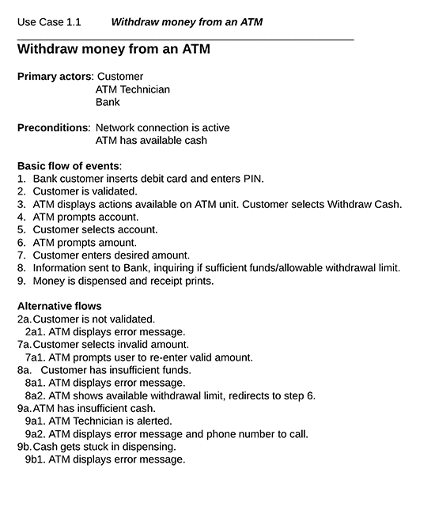

Example2: Use-case description:

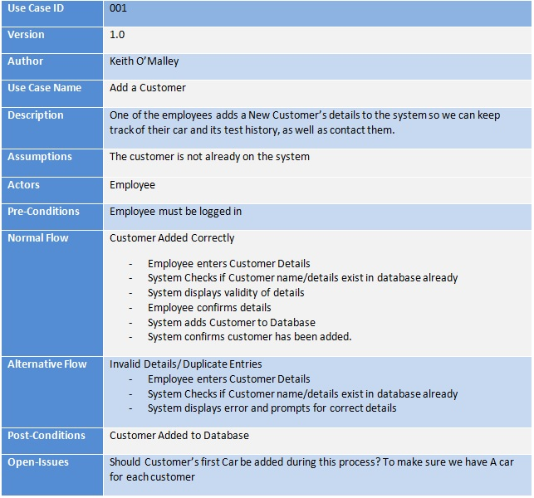

Example 3: Use-case diagram scenario

Example 4 – Use-case diagram.

